Sprint 1 Stories and Learning Plan

Consultant Version

Epic: Account and customer management
Stories:
- As a bank teller I should be able to create a new customer
  - “Customer class” specifications:
    - CUSTOMER_ID – is constant and unique. Customer should auto-generate the ids starting with the value 2_000_000 and increments by 7. The CUSTOMER_ID should be automatically initialized when a new customer is created. CUSTOMER_ID’s should not be passed in as arguments to the constructors.
    - Other Attributes - Name, Address and List of accounts
      - Create getter/setter methods for all
    - Constructor – customer’s name and address should be set when the customer is created.
    - addAccount() – takes in an Account and adds it to the list of accounts stored within the customer.
    - removeAccount() – takes in an Account and removes it to the list of accounts stored within the customer.
    - Customer should not be instantiated and only exist as a specific type like Person or Company
  - “Account Controller class” specifications:
    - In ‘controller’ package create the “AccountContoller” class
    - Attributes- List of customers
      - Create getter/setter methods
    - createCustomer() – takes in the customer’s name, address, and customer type.
      - IF the value for customer type is ‘person’ the method creates a new “Person” with the corresponding name and address, adds the object to the list of ‘customers’ and returns the “Person”
      - IF the value for customer type is ‘company’ the method creates a new “Company” with the corresponding name and address, adds the object to the list of ‘customers’ and returns the “Company”
    - getCustomers() – should return a list of all customers

- As a bank teller I should be able to delete an existing customer
  - “Account Controller class” specifications:
    - removeCustomer() - takes in a “Customer” and removes it from the “AccountContoller” list of ‘customers’ and removes all of the “Customer” ‘accounts’ from the “AccountController” list of ‘accounts’.

- As a bank teller I should be able to create a new account for a customer
  - “Account” specifications:
    - ACCOUNT_ID – is constant and unique. The class should auto-generate the ids starting with the value 1_000 and increments by 5. The ACCOUNT_ID should be automatically initialized when a new account is created. ACCOUNT_ID’s should not be passed in as arguments to the constructors.
    - Other Attributes- Balance
      - Create getter/setter methods for all
    - deposit() - increases the account’s balance by the value of the argument passed in
    - withdraw() - reduces the account’s balance by the value of the argument passed in. And, returning the value of the argument. Account is able to be overdrawn.
    - correctBalance() – changes the balance to match the value passed in as an argument
    - Account should not be instantiated and only exist as a specific type like SavingsAccount or CheckingAccount
      - “SavingsAccount” specifications:
        - Attributes- interestRate
          - Create getter/setter methods
        - withdraw() – should not be allowed to overdraw. IF the amount to withdraw is larger than the balance, nothing should be deducted and 0 should be returned.
        - addInterest() - calculates the interest due on the account and adds it to the balance. Interest due = balance * interest rate / 100.
      - “CheckingAccount” specifications:
        - Attributes- nextCheckNumber
          - Create getter/setter methods
        - getNextCheckNumber() – returns the value of the nextCheckNumber. Check numbers start at 1 and increments by 1.
  - “AccountController” specifications:
    - createAccount() – takes in a “Customer” and the account type.
      - IF the value for account type is ‘checking’ the method creates a new “CheckingAccount”, adds the object to the “AccountController” list of ‘accounts’ and the “Customer” list of ‘accounts’ and returns the “CheckingAccount”
      - IF the value for account type is ‘savings’ the method creates a new “SavingsAccount”, adds the object to the “AccountController” list of ‘accounts’ and the “Customer” list of ‘accounts’ and returns the “SavingsAccount”
    - Attributes- List of accounts
      - Create getter/setter methods

- As a bank teller I should be able to delete an existing account for a customer
  - “AccountController” specifications:
    - removeAccount() - takes in an “Account” and removes it from the AccountContoller’s list of ‘accounts’ and from all Customer’s list of ‘accounts’.

- As a bank teller I should be able to charge a fee from a customer’s accounts
  - “Person” specifications:
      - chargeAllAccounts() – subtracts the amount passed in from each account that person holds.
  - “Company” specifications:
      - chargeAllAccounts() – subtracts the amount passed in from all of the company’s “CheckingAccount”s. Doubles the amount passed in and subtracts doubled amount for the company’s “SavingsAccount”s.

UML:

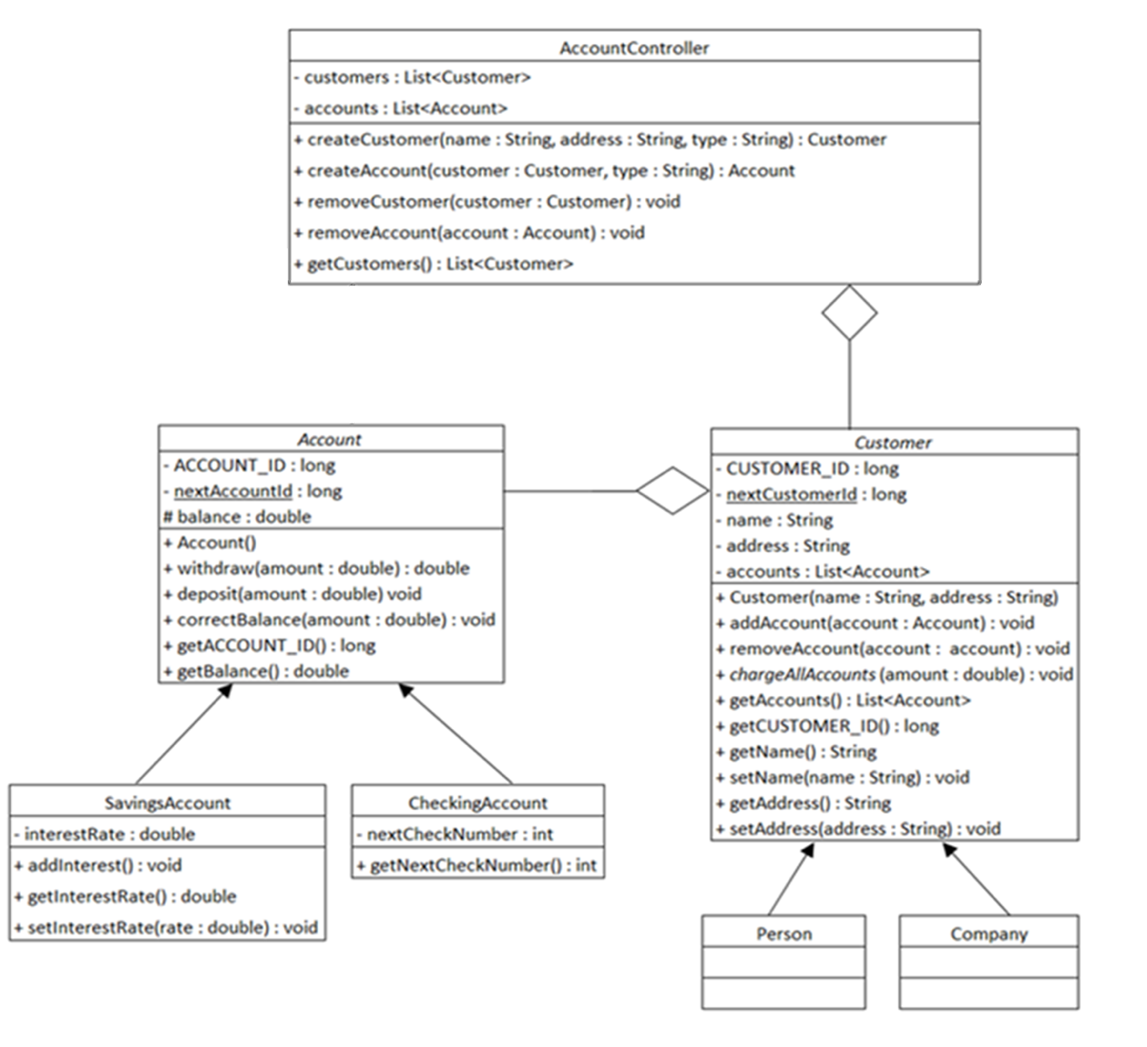
Note: All classes will be created in the controller package
Spike- As a developer I want to acquire necessary knowledge to be able to solidify Object Oriented Programming concepts and write programs in Java, while deepening my comprehension of Agile, AI and prompt engineering, thus enabling more efficient coding practices.

Description:
Sprint 1
Sprint Goal: Solidify Object Oriented Principles, comfortable with syntax and ability to solve simple logical problems and code the solution, while deepening the understanding of Agile, AI and prompt engineering, enabling more efficient coding
Day | 9:00 AM | 11:15 AM | 2:00 PM | 3:45 PM | 5:00 PM | Trainer Notes
1 | Orientation (Admins) | Welcome Session | House Rules | Written Communication | FDM Resume | The resume will serve as the written communication assessment
2 | FDM resume | Intro to Agile | Scrum Basics | Scrum Basics | APM Planning
3 | Iteration Execution | Iteration Execution | End Of Iteration | Presentation Skills | Career Essentials in Generative AI
4 | Career Essentials in Generative AI | Career Essentials in Generative AI | Write efficient Prompts | Write efficient Prompts | Write efficient Prompts
5 | Presentation Prep | Presentation Prep | Presentations |  |  | Cohort is divided into two groups to present on how AI could help them be more efficient at their jobs
6 | Sprint Planning | Data Types, Arrays and Lists | Conditionals | Loops | Problem solving with trainer | Day 1 could be used to create rapport and enhancing the learner’s knowledge by talking about String Immutability
7 | Methods | Classes | Git | Dependencies | Problem solving with trainer | More focus on one on ones to understand individual strengths and needs
8 | Static and Memory Management | Inheritance-classes | Polymorphism | Inheritance-Interfaces | Problem solving with trainer | More group discussions to encourage trainees to speak about the topics to analyze if they understood it.
9 | Work on stories and Trainer 1 on 1 | Work on stories and Trainer 1 on 1 | Work on stories and Trainer 1 on 1 | Work on stories and Trainer 1 on 1 | Problem solving with trainer
10 | Sprint Review | Sprint Review | Complete all pending exercises and submit | Complete all pending exercises and submit

Acceptance Criteria:
- Able to write and call methods, implements logics using conditionals and loops.
- Make classes and implement and identify dependencies between different classes.
- Define and implement Object Oriented principles- Inheritance, Encapsulation, Polymorphism and Abstraction.
- Submit all assigned exercises to trainer using Git

Assessment Rubrics:
- Written Communication: The FDM resume will serve as the assessment for written communication.
  - Cover Email
  - CV
  - Style
- Presentation Skills
  - Content and Structure
  - Delivery
  - Visual Aids and technology
  - Audience Interaction
  - Professionalism
- Project
  - Phase 1
    - Classes match the UML.
    - Abstract keyword is used for the classes and method specified in the UML.
    - Final, static and protected keywords are used where specified in the UML.
  - Phase 2
    - Account classes correctly implemented.
    - Customer classes correctly implemented.
    - Id generation correctly implemented.
    - AccountController class correctly implemented
    - Clean code

